Janeka Martin
TCN2 Task 3: Market Basket Analysis
Data Preparation and Exploration — D599

Part I: Research Question
A. Describe the purpose of your report by doing the following:
- Propose one question relevant to a real-world organizational situation that you will answer using market basket analysis.

Which products are most frequently purchased together in a single Allias Megastore order, and what cross-sell bundles should Allias promote to increase revenue?

- Define one goal of the data analysis. Ensure your goal is reasonable within the scope of the provided scenario and is represented in the available data.
Generate association rules from order-level product combinations and identify the top three actionable cross-sell rules to inform product bundling and targeted promotions.
Part II: Market Basket Justification
B. Discuss market basket analysis by doing the following:
- Explain how the Apriori algorithm, which is used for the market basket, analyzes the provided dataset, including expected outcomes.

The Apriori algorithm is a rule-based machine learning technique for identifying frequent itemsets and generating association rules from transactional data. According to DataCamp. (n.d.), Apriori is structured around the idea that we should retain frequent items. Apriori works by first identifying frequent itemsets that meet a minimum support threshold, then generating association rules from them. These rules are evaluated using metrics such as support, confidence, and lift to determine the strength of relationships between products.

In the Megastore dataset, each OrderID (one basket per OrderID) and has an associated ProductName. The Apriori algorithm finds item combinations that meet a minimum support threshold. From these frequent itemsets, association rules are generated and evaluated using metrics such as support, confidence, and lift.

The expected outcome of this analysis is the identification of product combinations that occur together more often than would be expected by chance. These results can inform cross-selling strategies, bundling decisions, product placement, and targeted marketing campaigns to increase average order value and overall sales performance.

- Provide one example of a transaction in the dataset.

Order # 536370 has 19 unique products. Below are examples of this transaction found in the Megastore dataset csv.
OrderID | ProductName
536370 | INFLATABLE POLITICAL GLOBE
536370 | SET2 RED RETROSPOT TEA TOWELS
536370 | PANDA AND BUNNIES STICKER SHEET
536370 | RED TOADSTOOL LED NIGHT LIGHT
536370 | VINTAGE HEADS AND TAILS CARD GAME
536370 | STARS GIFT TAPE
536370 | VINTAGE SEASIDE JIGSAW PUZZLES
536370 | ROUND SNACK BOXES SET OF4 WOODLAND
536370 | MINI PAINT SET VINTAGE
536370 | MINI JIGSAW CIRCUS PARADE
536370 | MINI JIGSAW SPACEBOY
536370 | SPACEBOY LUNCH BOX
536370 | CIRCUS PARADE LUNCH BOX
536370 | LUNCH BOX I LOVE LONDON
536370 | CHARLOTTE BAG DOLLY GIRL DESIGN
536370 | ALARM CLOCK BAKELIKE GREEN
536370 | ALARM CLOCK BAKELIKE RED
536370 | ALARM CLOCK BAKELIKE PINK
536370 | SET 2 TEA TOWELS I LOVE LONDON

- Summarize one assumption of market basket analysis.
I assume each OrderID in the dataset corresponds to a single shopping basket, so occurrences with the same OrderID should represent items purchased together in that basket. Another assumption of market basket analysis is that transactions are independent events, meaning that the items purchased in one order do not influence those purchased in another.
Part III: Data Preparation and Analysis
C. Prepare the dataset for further analysis by doing the following using R or Python:
- Wrangle (i.e., transform, encode) data by doing the following:

- Select x number of categorical variables, choosing two ordinal variables and two nominal variables.

Ordinal Variables
- OrderPriority
  - Represents a natural ranking of urgency (e.g., Low, Medium, High, Critical).
- CustomerOrderSatisfaction
  - Reflects customer feedback levels, including Dissatisfied, Prefer not to answer, Satisfied, Very Dissatisfied, and Very Satisfied.

Nominal Variables
- Region
  - Geographic regions (e.g., Northeast, Midwest, South, West) do not have a natural ranking. These categories represent distinct classifications rather than ordered levels.
- PaymentMethod
  - Includes categories such as Credit Card, PayPal, and Wire Transfer. These categories are distinct and unordered, making them appropriate for nominal encoding.

These four variables were selected because they represent different categorical data types (ordinal and nominal). These variables should allow for appropriate encoding techniques to be demonstrated while preserving the meaning and structure of the data.

- Perform the appropriate encoding method (i.e., ordinal, label encoding, one-hot encoding) for each variable selected in part C1a.
- Ordinal encoding for OrderPriority
- Ordinal encoding for CustomerOrderSatisfaction
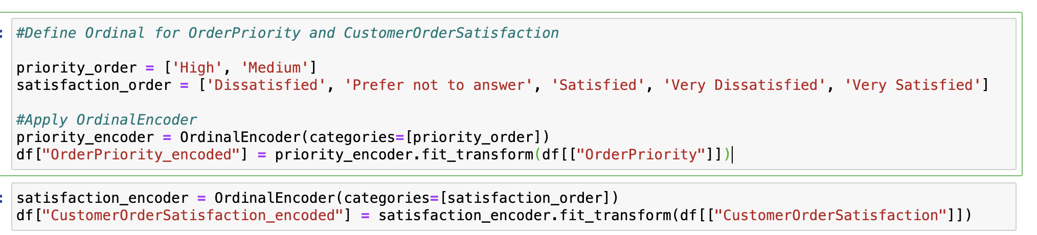
- One-hot encoding for Region
- One-hot encoding for PaymentMethod
To transform the OrderPriority categories into unique integers, encoding was applied as Medium = 1 and High = 2, preserving the dataset's urgency order.
CustomerOrderSatisfaction, the categories were encoded beginning at 1 using the following logical order: Very Dissatisfied = 1, Dissatisfied = 2, Prefer not to answer = 3, Satisfied = 4, and Very Satisfied = 5. This structure preserves the progression from the least favorable response to the most favorable response while placing the neutral response in the middle of the scale.
One-hot encoding was applied to Region and PaymentMethod. This created separate binary columns for each category value, such as region- and payment-method-specific indicator columns.
- Justify each step you took in part C1b.

I selected ordinal and nominal variables and transformed them into numeric values using appropriate encoding techniques. To use categorical data in statistical models and machine learning, values should be encoded as numeric so analytical algorithms can interpret and process the information successfully.

For OrderPriority, the values were encoded as Medium = 1 and High = 2 to preserve increasing urgency. For CustomerOrderSatisfaction, the values were encoded as Very Dissatisfied = 1, Dissatisfied = 2, Prefer not to answer = 3, Satisfied = 4, and Very Satisfied = 5 so that the satisfaction scale progressed logically from the lowest response to the highest response, with the neutral nonresponse placed in the middle.

One-hot encoding was applied to the nominal variables Region and PaymentMethod using pandas.get_dummies() function. One-hot encoding creates a new binary variable (0 or 1) for each category.

These encoding techniques converted qualitative categorical variables into a structured numerical format while maintaining the meaning and relationships inherent in the original data.

- Export the dataset that includes all encoded variables.

The updated dataset was exported as encoded_dataset.csv. The exported file includes the ordinally encoded columns OrderPriority_High_encoded and CustomerOrderSatisfaction_VerySatisfied_encoded, along with the one-hot encoded columns created for Region and PaymentMethod.

- Perform a market basket analysis by completing the following:
- Transactionalize the dataset with only the relevant variables for market basket analysis.

The dataset was converted into a transactional binary matrix, where each row corresponds to an OrderID (transaction) and each column corresponds to a ProductName. Values were encoded as 1 when the product appeared in a transaction and 0 otherwise, in the format required by market basket algorithms such as Apriori.

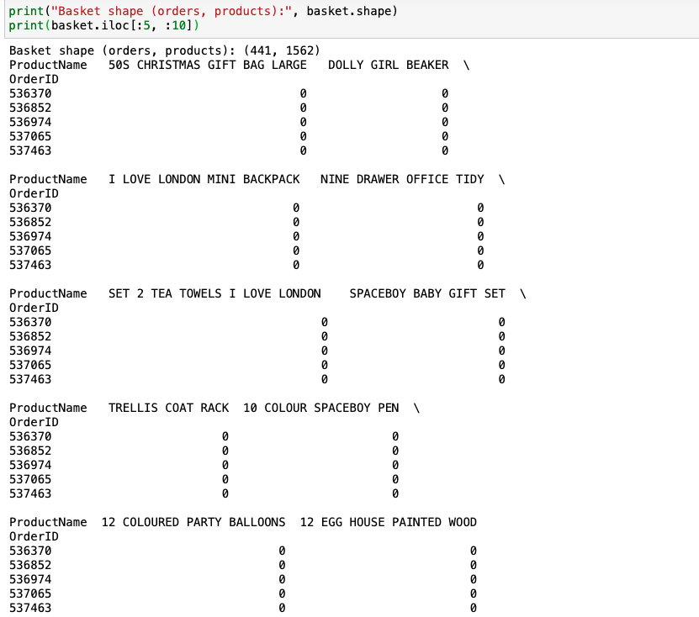
- Export the transactionalized dataset for market basket analysis with only the relevant variables.

Exported csv included in this submission.

- Execute the error-free code used to generate association rules with the Apriori algorithm. Provide a screenshot of the top three rules generated by the Apriori algorithm sorted by your chosen metric (i.e., confidence, support, or lift).
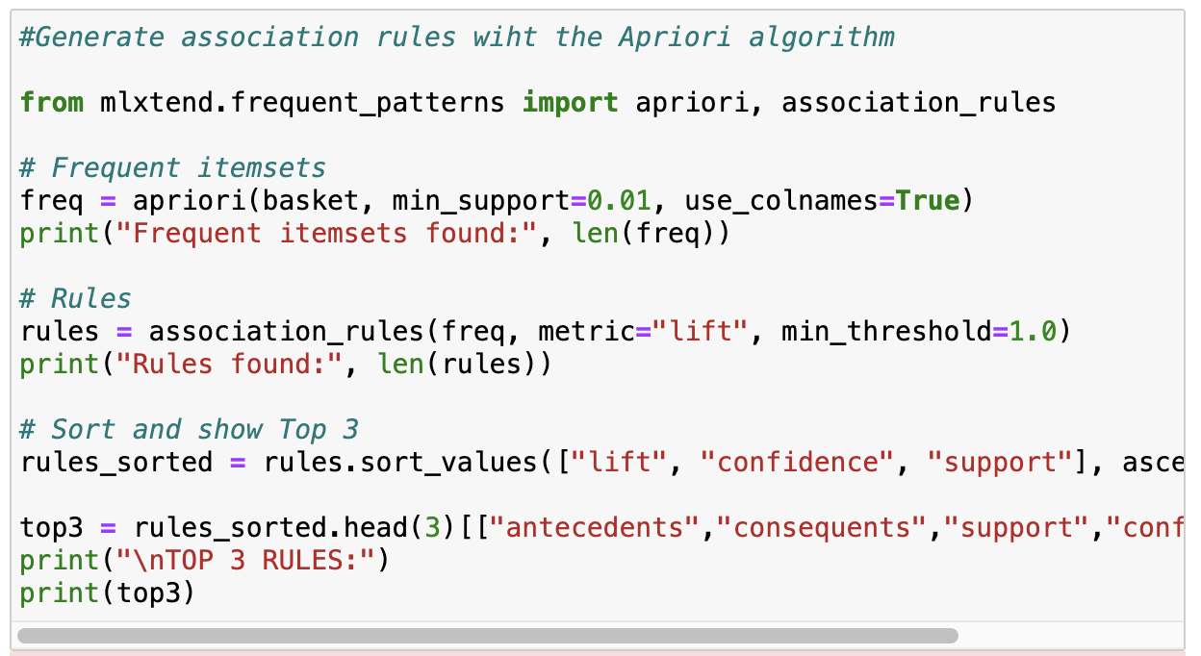
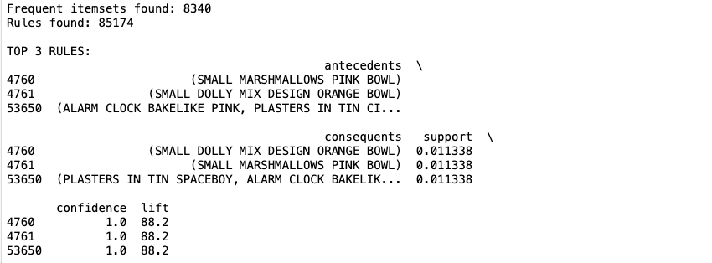
Part IV: Data Summary and Implications
D. Summarize your data analysis by doing the following:
- Justify the criteria used to generate the top three rules (e.g., "The association rules were sorted by lift in ascending order because...").
The association rules were sorted by lift in descending order to identify the strongest product relationships. Lift was selected because it measures how much more frequently two products are purchased together than would be expected if the purchases were independent. This algorithm was applied to the transactional dataset to identify frequent itemsets and generate association rules. The Apriori algorithm produced 8,340 frequent itemsets and 85,174 association rules, indicating numerous potential product relationships in the dataset. These rules identify patterns in customer purchasing behavior by showing which products are frequently purchased together in the same transaction.
- Explain support, lift, and confidence for the top three rules generated by the Apriori algorithm.

The first rule proves that customers who purchase the SMALL MARSHMALLOWS PINK BOWL, also purchase the SMALL DOLLY MIX DESIGN ORANGE BOWL. The support value of 0.011338 indicates that this product combination appears in 1.13% of all transactions within the dataset. The confidence value of 1.0 (100%) indicates that every transaction containing the pink bowl also contained the orange bowl. This suggests a very strong purchasing relationship between these two products. The lift value of 88.2 indicates that customers who purchase the pink bowl are 88 times more likely to purchase the orange bowl than would be expected if the products were purchased independently. This high lift value demonstrates an extremely strong positive association between these items.

The second rule represents the reverse relationship of the first rule. It indicates that customers who purchase SMALL DOLLY MIX DESIGN ORANGE BOWL also purchase SMALL MARSHMALLOWS PINK BOWL. The support value remains 0.011338, meaning that the two products appear together in approximately 1.13% of transactions. The confidence of 1.0 again indicates that every purchase of the orange bowl also includes a purchase of the pink bowl in the dataset. The lift value of 88.2 confirms that these products have a very strong association and are frequently purchased together at a rate far higher than random chance.

The third rule identifies a multi-item relationship involving ALARM CLOCK BAKELIKE PINK and PLASTERS IN TIN CIRCUS as the antecedent products. The PLASTERS IN TIN SPACEBOY and ALARM CLOCK BAKELIKE are the consequent products. This rule indicates that customers who purchase the first set of items are often likely to purchase the second set in the same transaction. The support value of 0.011338 indicates that this product combination appears in approximately 1.13% of transactions. The confidence value of 1.0 indicates that whenever the antecedent products are purchased together, the consequent products are also purchased in the same transaction. The lift value of 88.2 again demonstrates a strong positive relationship between these products, suggesting that they are commonly purchased together.

- Explain the practical significance of your findings from the analysis.

The association rules generated from the market basket analysis provide valuable insights into customer purchasing behavior. Retailers can use these findings to improve sales strategies and enhance customer experience.

For example, products that frequently appear together in transactions can be:
- placed near each other within physical store layouts
- bundled together as promotional offers
- Recommended to customers during online checkout
- highlighted through targeted marketing campaigns

In this case, the analysis identified several product combinations that customers frequently purchase together. Retailers could leverage this information by creating product bundles or suggesting related items during the shopping process to encourage additional purchases.

- Recommend a course of action for the real-world organizational situation from part A1 that is based on the results from part D1.
Based on the strongest rules identified by lift, Allias should bundle or cross-promote related products that frequently appear together in customer transactions. For example, the rule showing a strong association between SMALL MARSHMALLOWS PINK BOWL and SMALL DOLLY MIX DESIGN ORANGE BOWL suggests that customers purchasing one of these bowls are highly likely to purchase the other. Allias could bundle these items or offer a small promotional discount when both products are purchased together.
Similarly, the rule identifying the relationship between ALARM CLOCK BAKELIKE PINK and themed plaster products indicates that customers purchasing novelty or themed items may prefer coordinated products. Allias could cross-promote these items by recommending related products at checkout or by displaying them together on product pages.
By bundling or cross promoting these strongly associated products, Allias can test whether these strategies increase average order value and overall sales. These bundles directly address the question in A1 by targeting product combinations with elevated co-purchase likelihood identified through market basket analysis.
Part V: Submission
E. Submit your work by doing the following:
- Provide a document that includes responses to task prompts through the Assessments section of the student portal.

This is the document that includes responses to task prompts.

- Provide the two CSV files (i.e., the non-transactionalized dataset with encoded variables from parts C1 and C2 and the transactionalized dataset of relevant variables used to perform market basket analysis) through the Assessments section of the student portal.

The CSV exports are attached to this submission.

- Provide the error-free annotated code as an executable script file. R files and Python script files are accepted.
https://gitlab.com/wgu-gitlab-environment/student-repos/jmart375/d599-data-preparation-and-exploration/-/blob/c1c31db16d855b1a212478253ff10edc5461c420/D599Task3.ipynb
- Provide a link to a Panopto video recording that includes a demonstration of the functionality of the code used for the analysis and an identification of the version of the programming environment. The demonstration must include a vocal presentation of all the listed elements. For the duration of the presentation, ensure the video captures both you as the presenter and the functioning code in a Panopto video recording. Share this link through the Assessments section of the student portal.
The below drop box "Data Preparation and Exploration TCN2 | D599 (Student Creators)." Could not be found.
Here is the link to the recording: https://wgu.hosted.panopto.com/Panopto/Pages/Viewer.aspx?id=0c96e7f7-7ac8-4a9d-bcf1-b40800e848f3
To submit your recording, upload it to the Panopto drop box titled "Data Preparation and Exploration TCN2 | D599 (Student Creators)." Once the recording has been uploaded and processed in Panopto's system, retrieve the URL of the recording from Panopto and copy and paste it into the Links option. Upload the remaining task requirements using the Attachments option.
Sources
F. Acknowledge reference sources used to support the Python or R code application. All references listed should also include an in-text citation in the code annotation. Be sure the sources are reliable. If no sources were used for coding, state, "No sources used."
No sources used.
G. Acknowledge sources, using in-text citations and references, for content that is quoted, paraphrased, or summarized.
DataCamp. (n.d.). Market basket analysis in Python. https://www.datacamp.com/courses/market-basket-analysis-in-python

